**PROCESS INSTRUMENTATION**

**Name: Vivek Chandrashekhar Rugale**

**GR No.: 11810369**

**Div.: TY-C**

**Roll No.: 24 (Batch B1)**

**LAB 3:**

**Aim – Study and design the square root extractor**

Op-amp based implementation of square root extractor in Tinkercad-

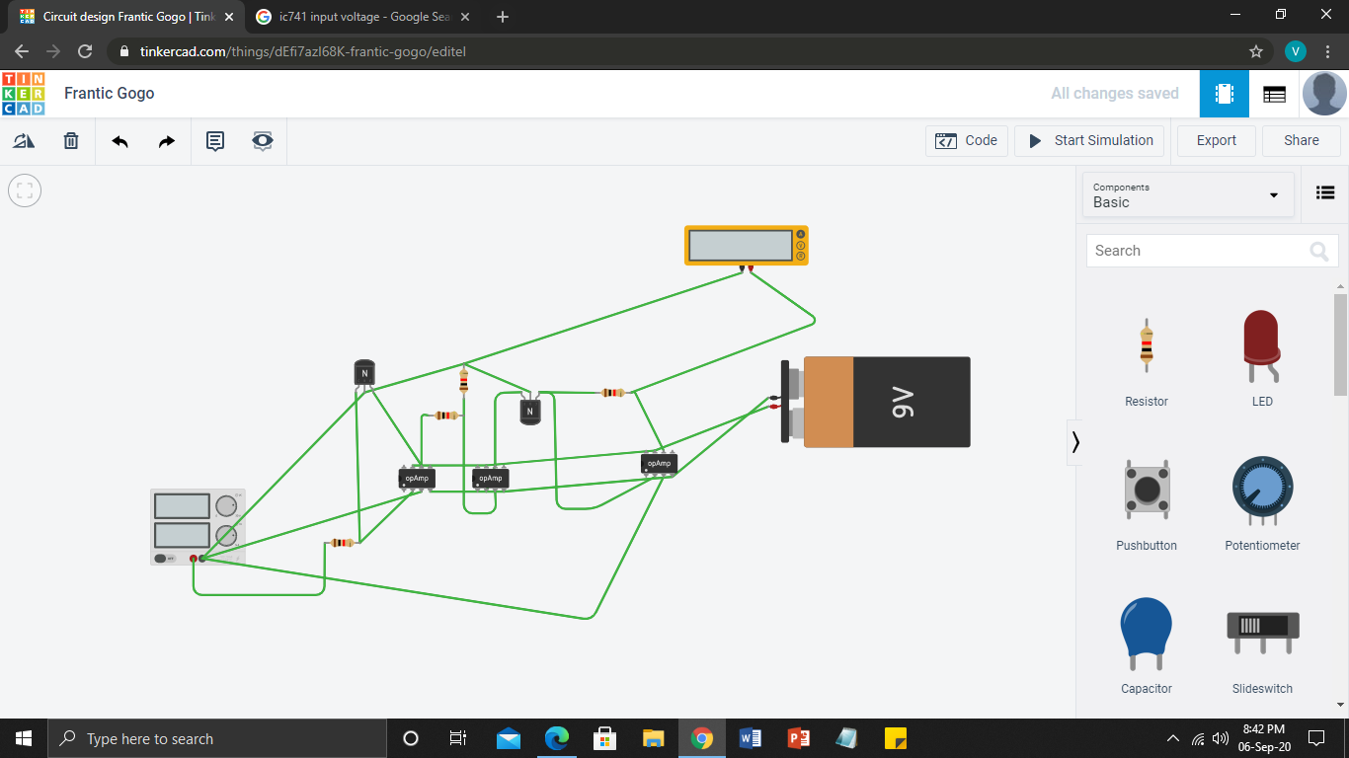

**Python Code –**

import math

x = float(input('Input current to SRE ='))

x1 = 4*(math.sqrt(x-4))

y = x1+4

print('The output current is =',y)

**Pneumatic Square Root Extractor**

The square root extractor is a device that takes the square root of the signal from the flow transmitter and outputs a corresponding linear flow signal. Following image shows a Moore Products model 65 (1) pneumatic square root extractor.

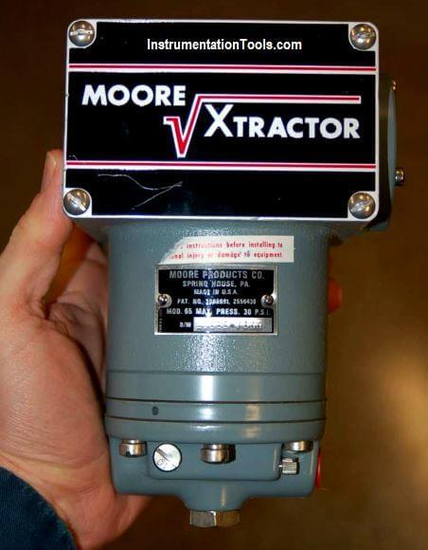

The following table shows the ideal response of a **pneumatic square root relay**:

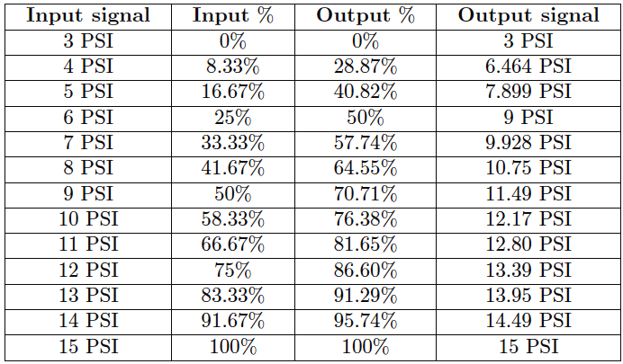

As you can see from the table, the square-root relationship is most evident in comparing the input and output percentage values. For example, at an input signal pressure of 6 PSI (25%), the output signal percentage will be the square root of 25%, which is 50% (0.5 = √0.25) or 9 PSI as a pneumatic signal.

At an input signal pressure of 10 PSI (58.33%), the output signal percentage will be 76.38%, because of 0.7638 = √0.5833, yielding an output signal pressure of 12.17 PSI.